DIGITAL COMMUNICAITON

**AIM**

* Understand the importance of digital communication
* How does digital differ from analogue
* Introduction to push buttons and reading its state

**MATERIALS**

* Arduino
* Breadboard
* Push Button
* Resistor

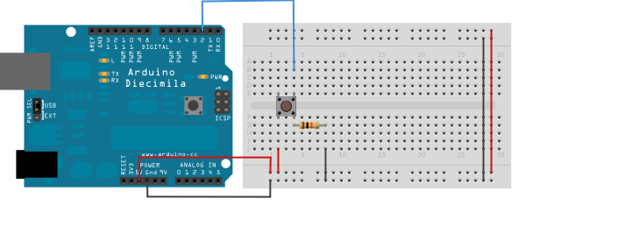**CIRCUIT DIAGRAM**

**PUSHBUTTON**

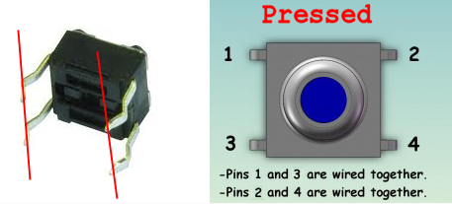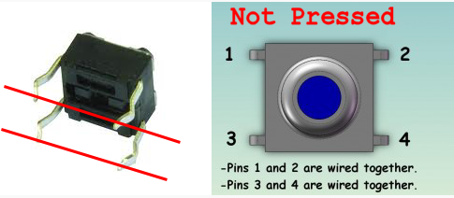Button not pressed = disconnected circuit  
Button pressed = connected circuit.

**DEBOUNCING – A common problem**

Bouncing is the tendency of any two metal contacts in an electronic device to generate multiple signals as the contacts close or open; debouncing is any kind of hardware device or software that ensures that only a single signal will be acted upon for a single opening or closing of a contact.

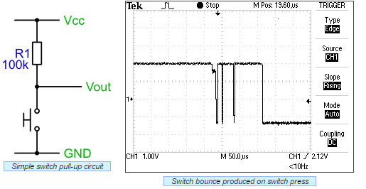

Pressing the switch does not provide a clean edge. If this signal was used as an input to a digital counter, for example, you'd get multiple counts rather than the expected single count. Note that the same can also occur on the release for a switch.  
The problem is that the contacts within the switch don't make contact cleanly, but actually slightly 'bounce'. The bounce is quite slow, so you can recreate the trace, and the problem quite easily.  
  
**CODE:**   
